Curriculum Vitae

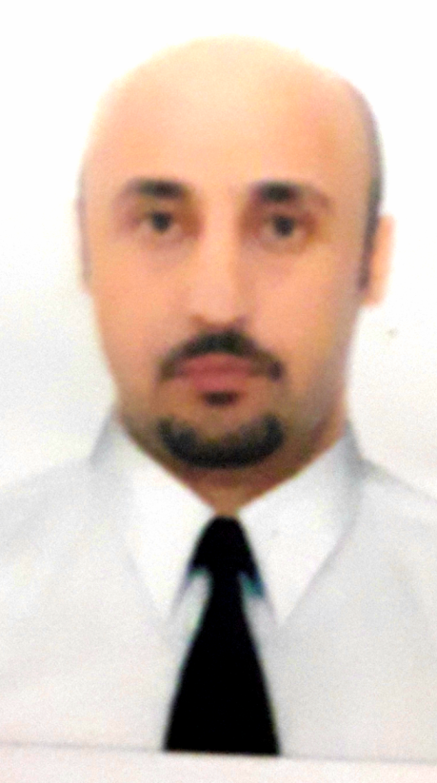
Personal Information:
Name: Ali Abdalslam Emhamed.
Surename: Elhaj Emhamed.
Date of birth: 23.02.1979.
Nationality: Libyan.
Marital status: Married has 3 children.
E mail: ali2009218@yahoo.com.
Academic Qualification:
- Bachelor degree in Medicine and Surgery (M.B.B.Ch.) in January 2005, University of Tripoli – Faculty of Medicine.
- Completed the full post- graduate course of specialization in ophthalmology(clinical ordinatura) from 04.07.2011 to 03.07.2013, Odessa National Medical University, Odessa-Ukraine.
- Ph. D degree of ophthalmology: from 15.07.2013 to 02.02.2018,
The Filatov Institute of Eye Diseases and Tissue Therapy of the National Academy of Medical Sciences of Ukraine.

Professional Experience:
- Operate ophthalmic instruments including auto-kerartorefractometers and ophthalmoscopes.
- Test for intraocular pressure ocular motility and pupil size equality and reaction
- Conducted ocular motility tests to measure function of eye muscles.
- Provided full-scope management of ocular infection inflammation and ocular trauma.
- Diagnosed glaucoma anterior and posterior segment disease and neurological eye disease.
- Assessed refractive conditions of eyes with retinoscopes.
- Analyze test results to develop proper eye care treatment plans.
- Determined visual acuity and perception focus and coordination.
- Prescribed appropriate medications to treat eye diseases and infections.
- Routinely followed up with patients about their post-operative recovery status.
Surgical Experience:
- Surgical procedures performed independently: in Ophthalmology hospital – Tripoli, during the period from 01.06.2006 to 01.06.2010.
- Cataract surgery (ECCE) with IOL’s.
- Dacrycyctorhinostomy(DCR).
- Pterygium with and without graft.
- Entropion and Ectropion surgries.
- Surgical procedures performed under supervision: in The Filatov Institute of Eye Diseases and Tissue Therapy of the National Academy of Medical Sciences of Ukraine, during the period from 15.07.2013 to 15.10.2017.
- Vitreoretinal surgeries (Vitrectomy, Intravitreal injections).
- Squint surgries.
Courses:
Microsurgery and phacoemulsification.
29 November – 28 December 2017
Kyiv, Ukraine
Languages:
- Arabic.
- English.
- Russian.

